**CREATE TABLES AND DESCRIBE**

**INSERT INTO EMPLOYEE TABLE AND SELECT* (WITH SUPPORT)**

**INSERT INTO EMPLOYEE TABLE AND SELECT* (WITHOUT SUPPORT)**

**INSERT INTO EMPLOYEE TABLE AND SELECT* (CHARACTER)**

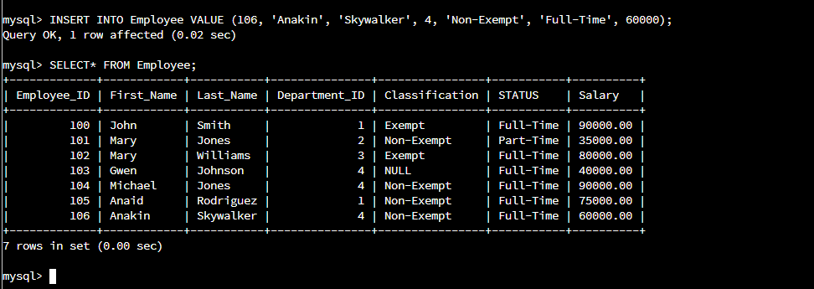

**SELECT NAMES AND ID’S**

